1
a) Why is crude oil called a ‘fossil fuel’? (2)

b) Why do we have to be careful about how much crude oil we use? (1)

Crude oil is a mixture of different compounds. These are separated as shown in the diagram below according to their chain length.
c) What happens to the boiling point as the chain length increases? (1)

d) Using the diagram above, explain how petrol is separated out from crude oil. (6)

2 One group of compounds found in crude oil are the alkanes. They are simplest homologous series. They are hydrocarbons.
a) What is an ‘homologous series’? (2)

b) What two elements are hydrocarbons made from? (2)

c) Below is a table showing the first four alkanes. Fill in the missing gaps. (5)
Alkane | Display structure | Structural formula | Molecular formula
Methane | 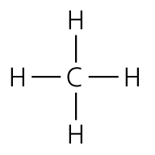 | CH₄ | CH₄
Ethane |  | CH₃CH₃ | C₂H₆
 | 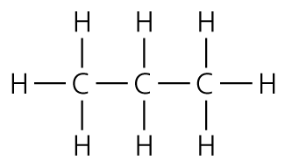 | CH₃CH₂CH₃
Butane | 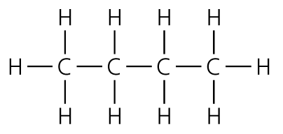
d) What is the general formula for alkanes? (1)

e) How does the viscosity change as the chain gets longer? (1)

f) Alkanes can be burnt in oxygen to produce energy and two products. Write the word equation for the complete combustion of ethane. (2)
Ethane + oxygen → ___________________ + _________________
g) If not enough oxygen is present then the results is incomplete combustion. This produces carbon monoxide (CO). Why is this dangerous? (1)

h) Write the balanced chemical equation for the incomplete combustion of ethane. (3)

3 Another homologous series are the alkenes. They are unsaturated.
a) What does unsaturated mean? (1)

b) What is a chemical test for alkenes? (2)

c) Below is a table of some alkenes. Fill in the gaps. (3)
Alkene | Display structure | Structural formula | Molecular formula
 | 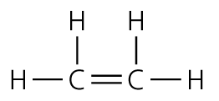 |  | C₂H₄
Propene | 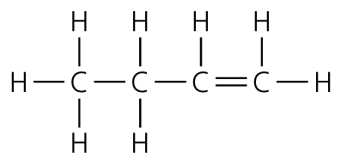 | CH₃CHCH₂
Long chain alkanes are ‘cracked’ to make more useful shorter chain alkanes and alkenes.
d) Write the chemical equation for the cracking of octane (C₈H₁₈) into ethane and an alkane.
C₈H₁₈ → C₂H₄ + _________________ (1)
e) Alkenes can be made into polymers. Molecules of propene combine to form polypropene. Draw the repeating unit of polypropene. (2)
n(CH₃CHCH₂) →

f) Polypropene is a man-made polymer and is formed by an additional polymerisation reaction.
Polyamides are made by condensation polymerisation.
What is the difference between these two methods of polymerisation? (2)

4 Alcohols are another homologous series. One alcohol is ethanol. This can be made from sugar.
a) What is the process called that makes ethanol from sugar? (1)

b) What are the conditions needed for this reaction? (2)

c) Apart from being used in drinks, alcohols are used in inks. Why? (1)

d) Write the chemical equation for the complete combustion of ethanol. (3)

e) Alcohols oxidise to carboxylic acids. What would you see when sodium carbonate is added to ethanoic acid (CH₃COOH)? (1)

f) Alcohols react with carboxylic acids to make esters. Below is a chemical and word equation for one such reaction. Fill in the gaps. (3)
Ethanoic acid + ethanol → _________________ + water
CH₃COOH + _________ → CH₃COOCH₂CH₃ + __________
g) Give a use for esters. (1)

Total = 50

1
a) It is a fuel that is made from dead sea creatures that died millions of years ago. (2)
b) It is non-renewable / it will run out / valuable resource. (1)
c) Boiling point increases as chain length increases. (1)
d)
Marks
6–5 | At least three different points well expressed
4–3 | A couple of points mentioned
2–1 | Not much detail

- The crude oil is heated and vaporised.
- The vaporised crude oil enters the fractionating tower.
- This is hotter at the bottom and cooler at the top.
- The hydrocarbons cool as they rise up the tower.
- They condense at different heights because they have different boiling points.
- Hydrocarbons with large molecules are collected as liquids near the bottom of the tower while those with small molecules collect at the top.
2
a) A homologous series is a family of compounds with the same general formula / the same functional group / similar chemical properties. (any 2, 1 mark each)
b) Hydrogen and carbon (2)
c) (1 mark for each correct answer) (5)
Alkane | Display structure | Structural formula | Molecular formula
Methane |  | CH₄ | CH₄
Ethane | 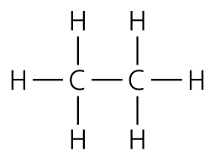 | CH₃CH₃ | C₂H₆
Propane |  | CH₃CH₂CH₃ | C₃H₈
Butane |  | CH₃CH₂CH₂CH₃ | C₄H₁₀
d) C_{n}H_{2n+2} (1)
e) The alkane gets thicker/more viscous. (1)
f) carbon dioxide + water (2)
g) Carbon monoxide – poisonous / stops oxygen getting round body. (1)
h) C₂H₆ + 2½O₂ → 2CO + 3H₂O or × 2 (LHS = 1 mark, RHS = 1 mark, balance = 1 mark)
3
a) Contains C=C double bonds. (1)
b) Decolourises bromine water. (2)
c) (1 mark for each correct answer) (3)
Alkene | Display structure | Structural formula | Molecular formula
Ethene |  | CH₂CH₂ | C₂H₄
Propene |  | CH₃CHCH₂ | C₃H₆
d) C₆H₁₄ (1)
e)
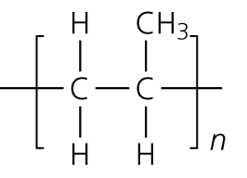 (1 mark for no double bond, 1 mark for rest)
f) Addition: many monomers with double C=C bonds add together; condensation: small molecule (often water) given off. (2)
4
a) Fermentation (1)
b) No oxygen/warmth/yeast (any 2, 1 mark for each)
c) Used in inks, etc.; evaporate easily / dissolve substances better than water. (1)
d) C₂H₅OH + 3O₂ → 2CO₂ + 3H₂O (LHS = 1, RHS = 1, balance = 1)
e) Bubbles/effervesces (1)
f) Ethanoic acid + ethanol → ethyl ethanoate + water
CH₃COOH + C₂H₅OH → CH₃COOCH₂CH₃ + H₂O (3)
g) Esters are used in perfumes/soaps/flavourings. (1)
Total = 50

